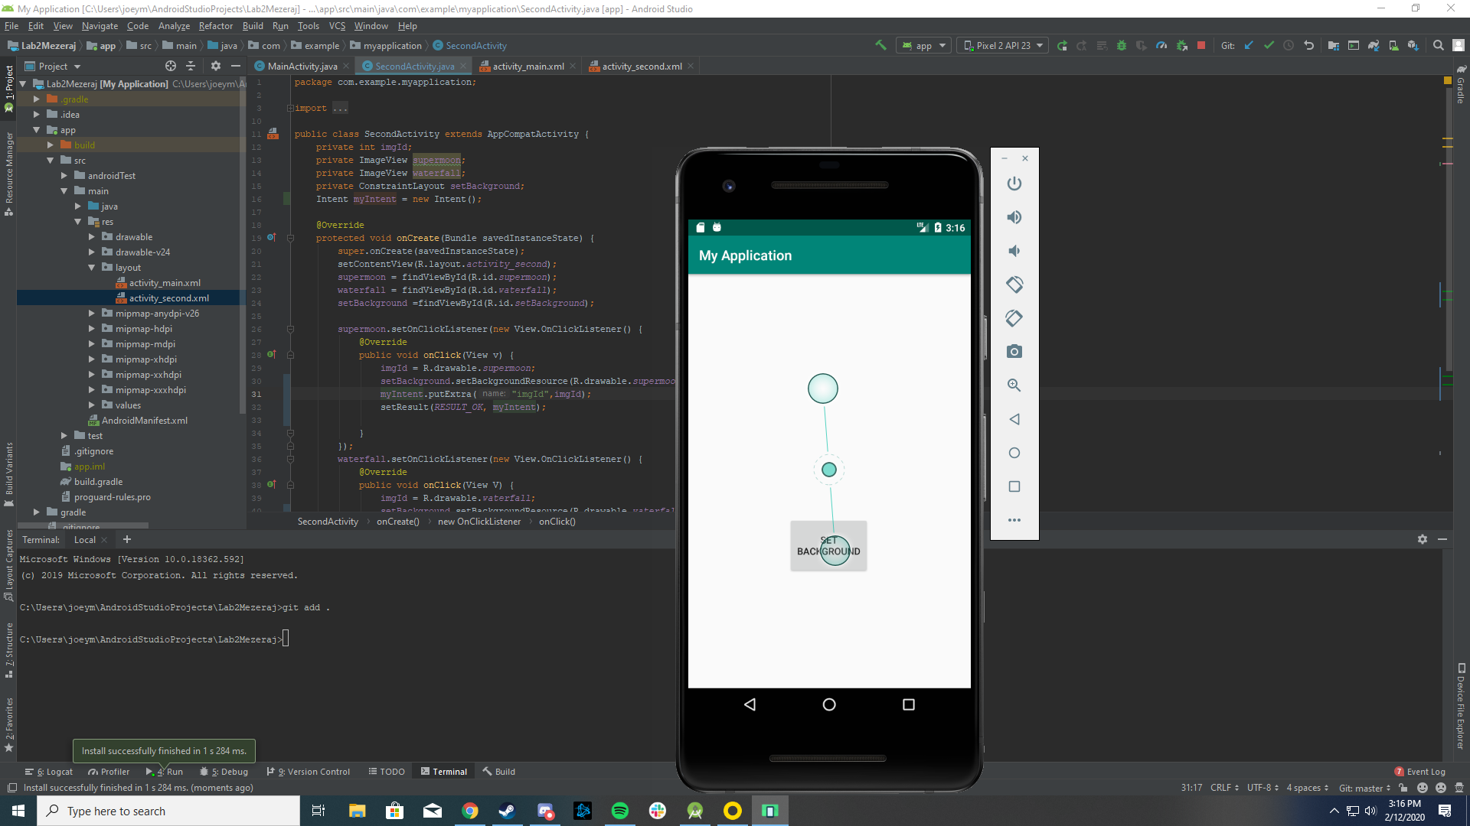

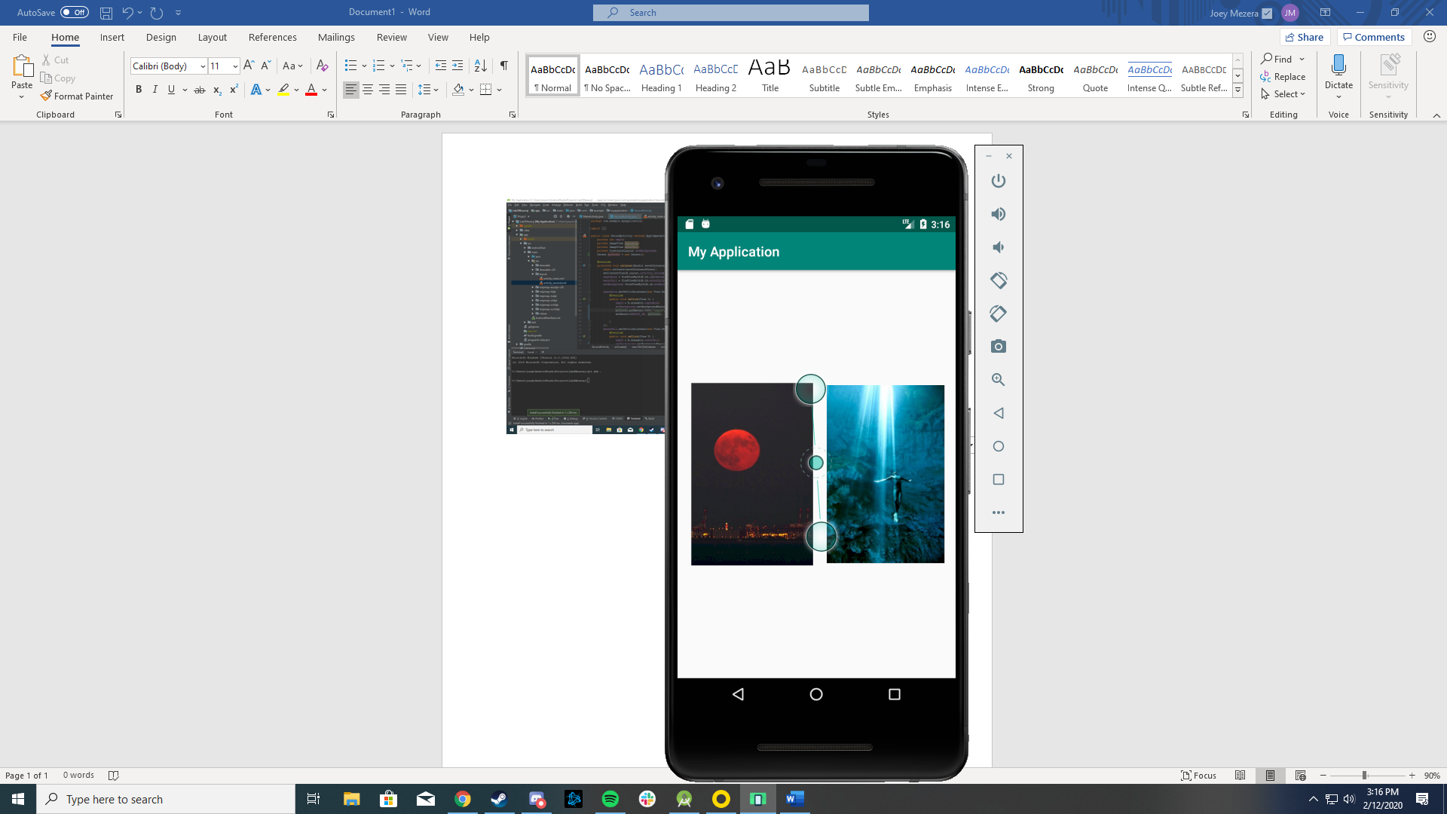

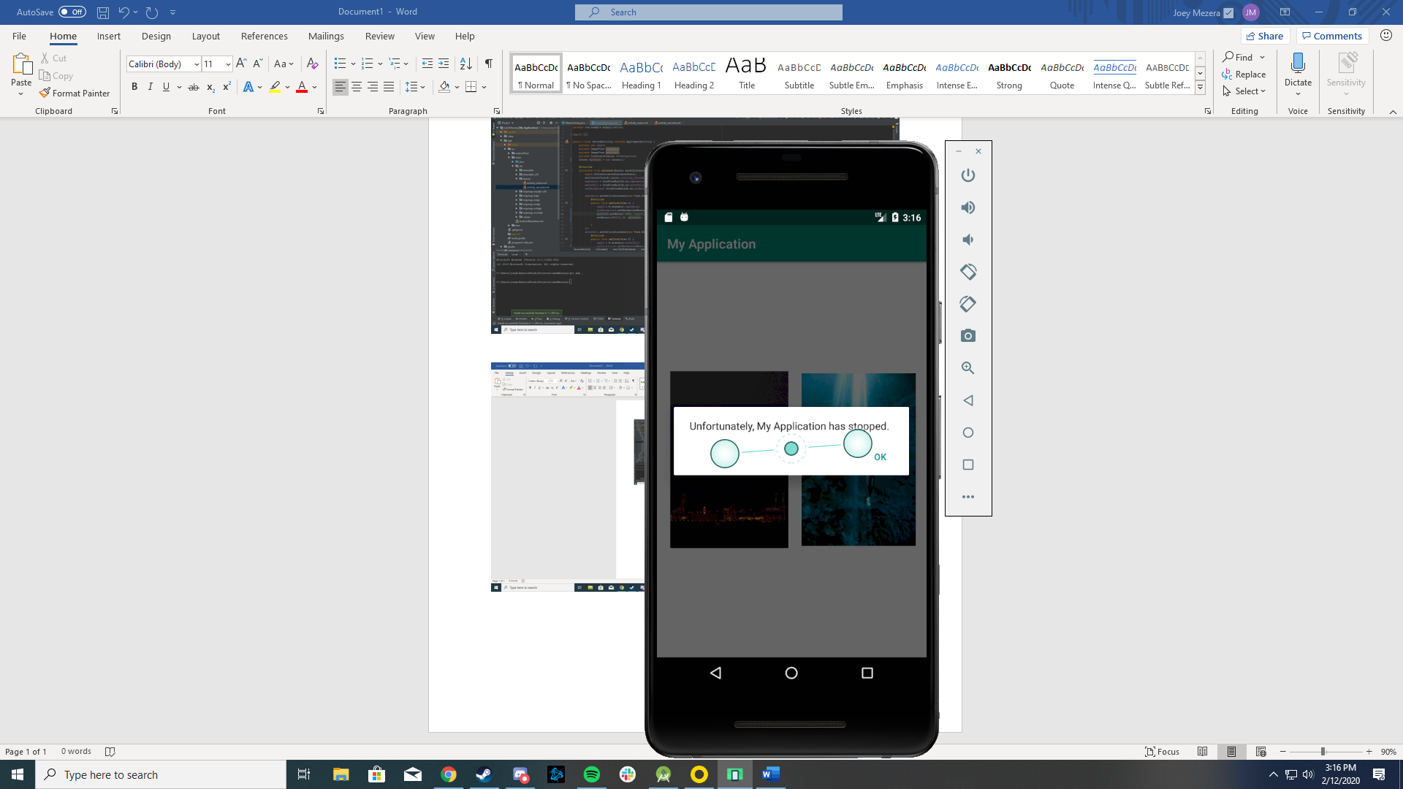

When I click on a picture it takes me back to the home screen after I click okay. I have all the things you had in class. Not sure why it doesn’t work and I don’t understand what isn’t working so I don’t know how to fix it.